1) Install httpd using ansible playbook, use handlers,notifiers.
Step 1: Create Project Directory
On your Ansible Controller node:
mkdir httpd-playbook
cd httpd-playbook
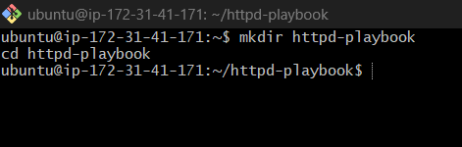

Step 2: Create Inventory File
Create hosts file:
vi hosts
Add worker node IPs:
[webservers]
172.31.40.75
172.31.39.156
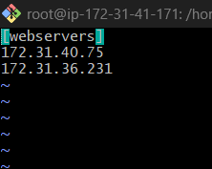

Step 3: Check Connectivity
Run ping test:
ansible all -i hosts -m ping
Expected:
172.31.x.x | SUCCESS => {
"ping": "pong"
}
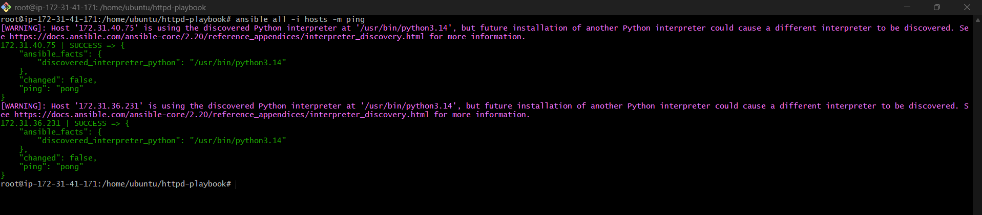

Step 4: Create Playbook File
Create playbook:
vi httpd.yml
Add this playbook:
---
- name: Install and Configure Apache HTTPD
hosts: webservers
become: yes

tasks:

- name: Install apache2 package
apt:
name: apache2
state: present
update_cache: yes
notify:
- Start Apache Service

- name: Copy index.html file
copy:
content: "Welcome to Apache Server from Ansible"
dest: /var/www/html/index.html
notify:
- Restart Apache Service

handlers:

- name: Start Apache Service
service:
name: apache2
state: started
enabled: yes

- name: Restart Apache Service
service:
name: apache2
state: restarted
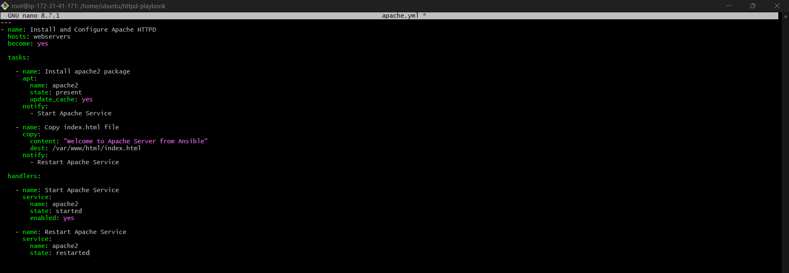

Step 5: Run the Playbook
Execute:
ansible-playbook -i hosts httpd.yml
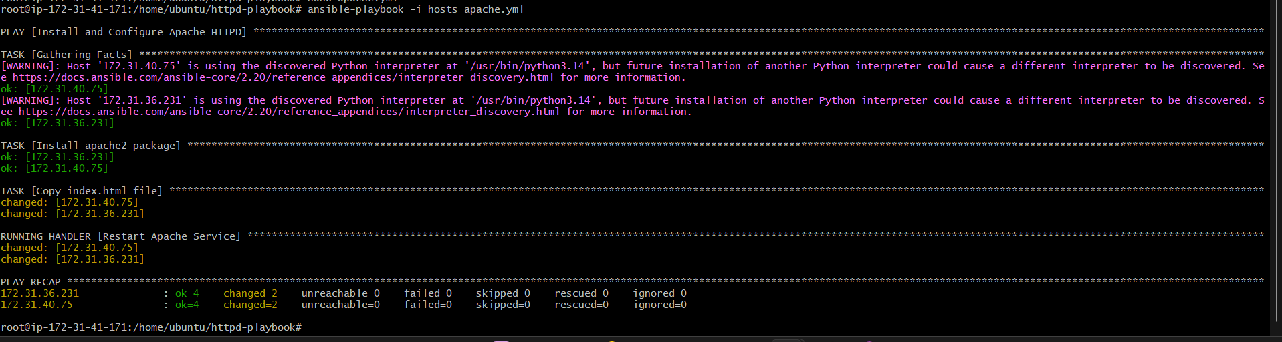

Step 6: Verify on Worker Node
Login to worker node:
ssh ansible@172.31.40.75
Check service:
systemctl status httpd
Expected:
active (running)
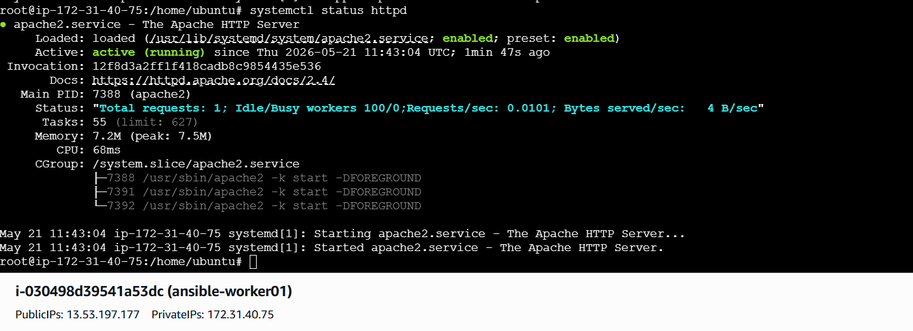
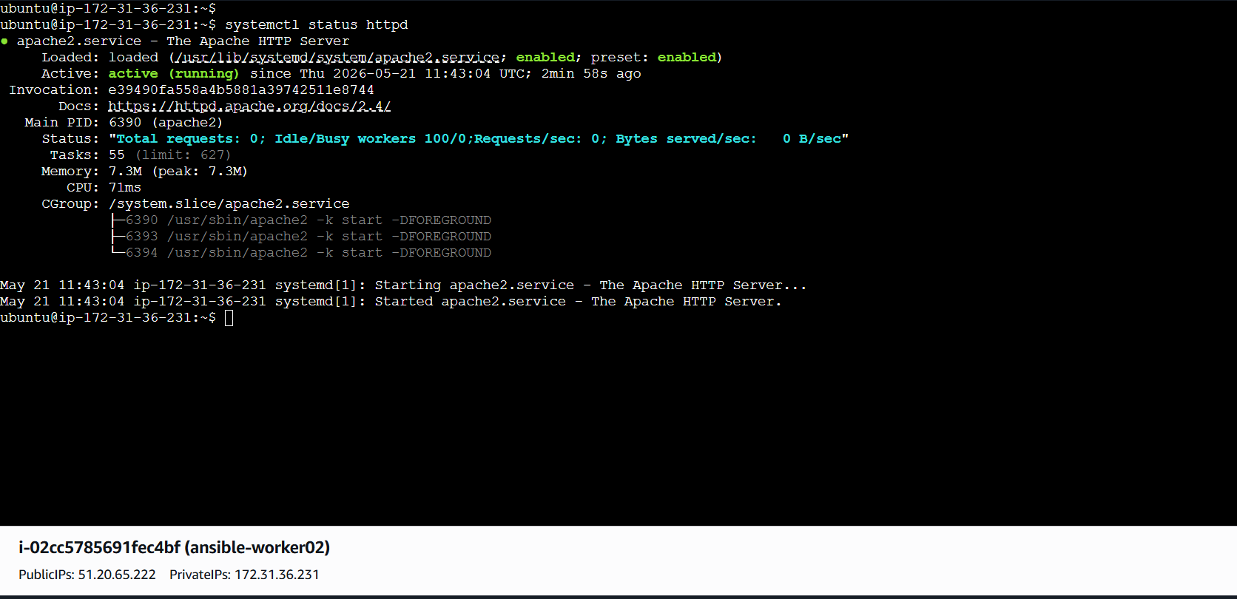

Step 7: Verify in Browser
Open:
http://<worker-node-public-ip>
Example:
http://3.111.xx.xx

You should see:
Welcome to Apache Web Server from Ansible
http://51.20.65.222/



http://13.53.197.177/

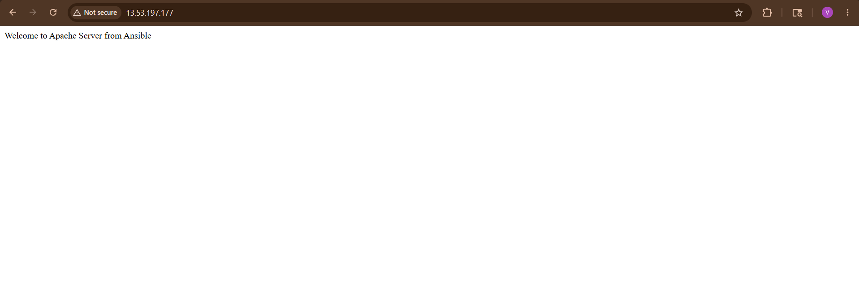

Understanding Handlers & Notify
What is notify?
When a task changes something, it triggers a handler.
Example:
notify:
- Restart HTTPD Service

What is a Handler?
Handlers run only when notified.
Example:
handlers:
- name: Restart HTTPD Service

Why Use Handlers?
Benefits:
- Avoid unnecessary restarts
- Efficient automation
- Industry standard practice
- Services restart only when changes happen

2) Write a ansible playbook to install apache tomcat.
Install Apache Tomcat Using Ansible Playbook
We will automate:
✅ Java Installation
✅ Tomcat Download
✅ Extract Tomcat
✅ Start Tomcat Service
✅ Verify in Browser
Step 1: Create Project Directory
On Ansible Controller:
mkdir tomcat-playbook
cd tomcat-playbook
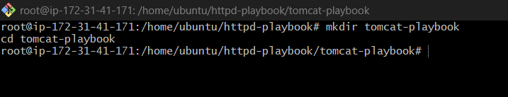

Step 2: Create Inventory File
nano hosts
Add:
[tomcat]
172.31.40.75
172.31.36.231
Save file.
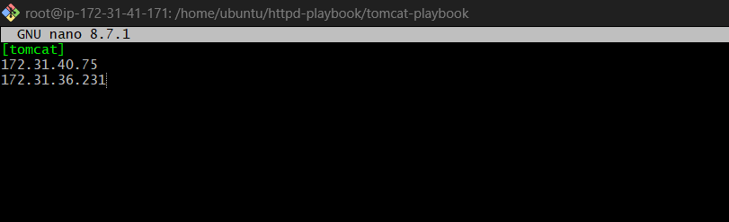

Step 3: Verify Connectivity
ansible tomcat -i hosts -m ping
Expected:
SUCCESS => {
"ping": "pong"
}
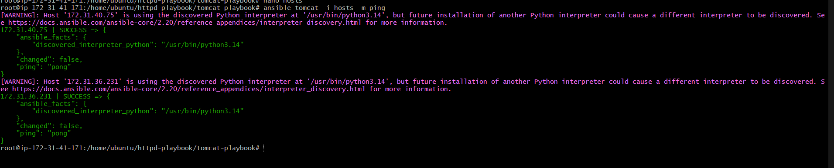

Step 4: Create Playbook
nano tomcat.yml
Add this full playbook:
---
- name: Install Apache Tomcat
hosts: tomcat
become: yes
vars:
tomcat_url: https://archive.apache.org/dist/tomcat/tomcat-9/v9.0.85/bin/apache-tomcat-9.0.85.tar.gz
tasks:
- name: Update apt packages
apt:
update_cache: yes
- name: Install Java
apt:
name: openjdk-17-jdk
state: present
- name: Create Tomcat Directory
file:
path: /opt/tomcat
state: directory
mode: '0755'
- name: Download Tomcat
get_url:
url: "{{ tomcat_url }}"
dest: /opt/apache-tomcat.tar.gz
- name: Extract Tomcat
unarchive:
src: /opt/apache-tomcat.tar.gz
dest: /opt/tomcat
remote_src: yes
extra_opts: [--strip-components=1]
notify:
- Start Tomcat
handlers:
- name: Start Tomcat
shell: nohup /opt/tomcat/bin/startup.sh

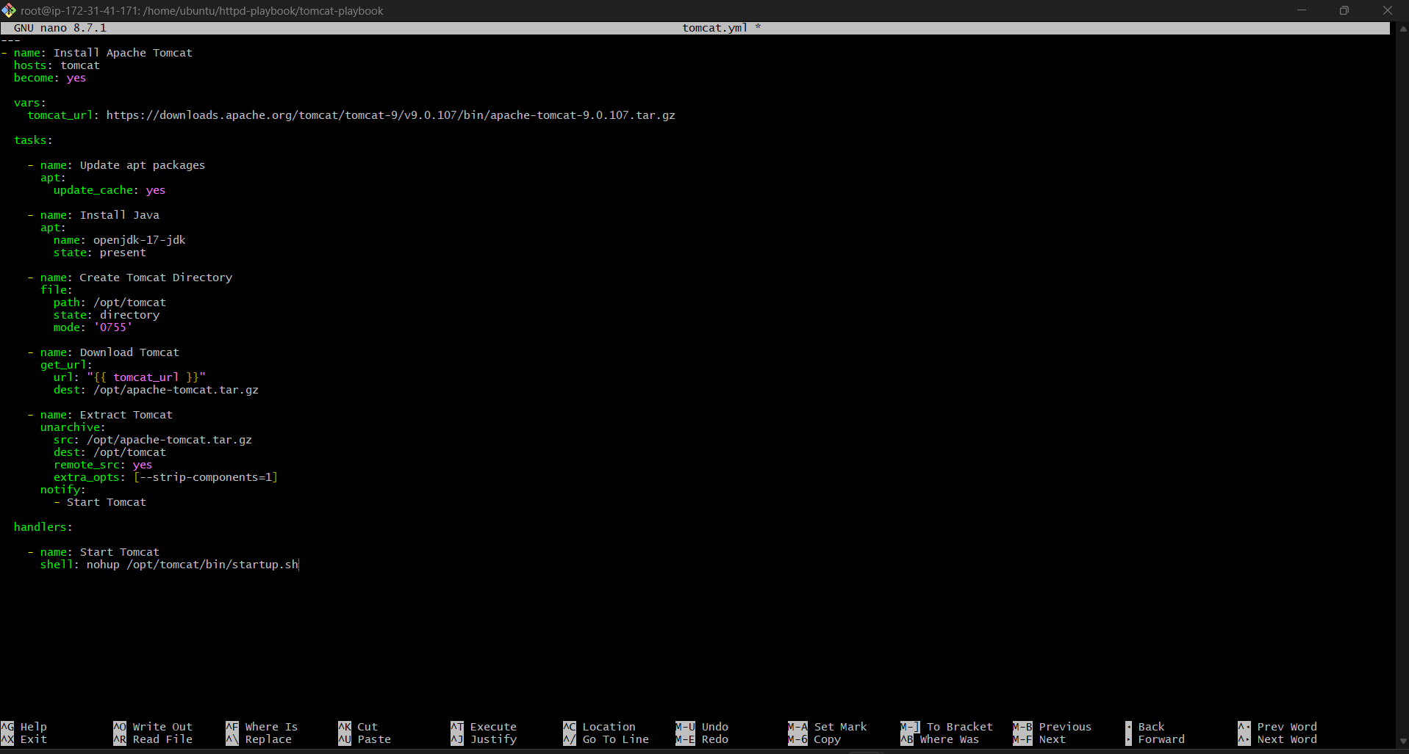

Step 5: Run Playbook
ansible-playbook -i hosts tomcat.yml
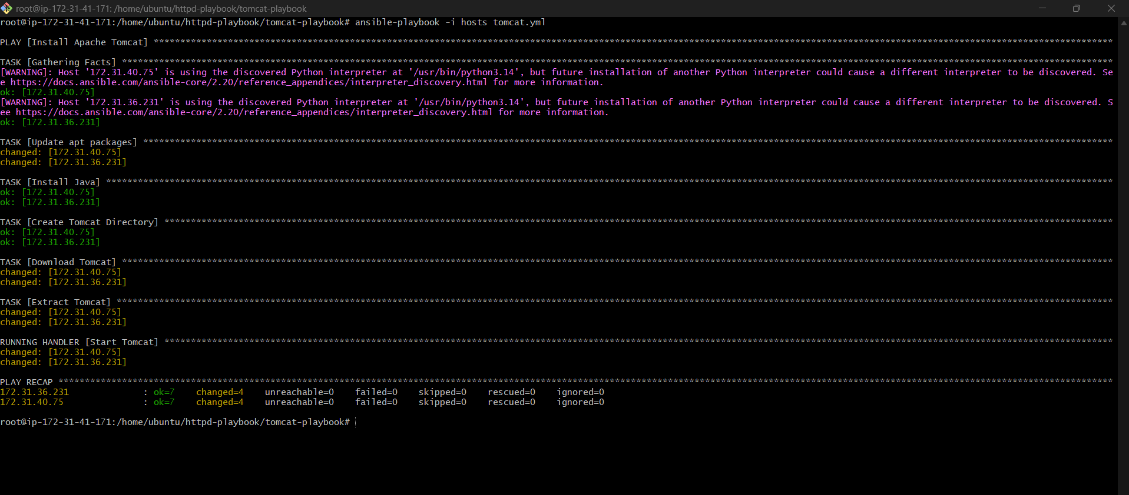

Step 6: Verify Tomcat Process
SSH to worker node:
ssh ubuntu@172.31.40.75
Check process:
ps -ef | grep tomcat
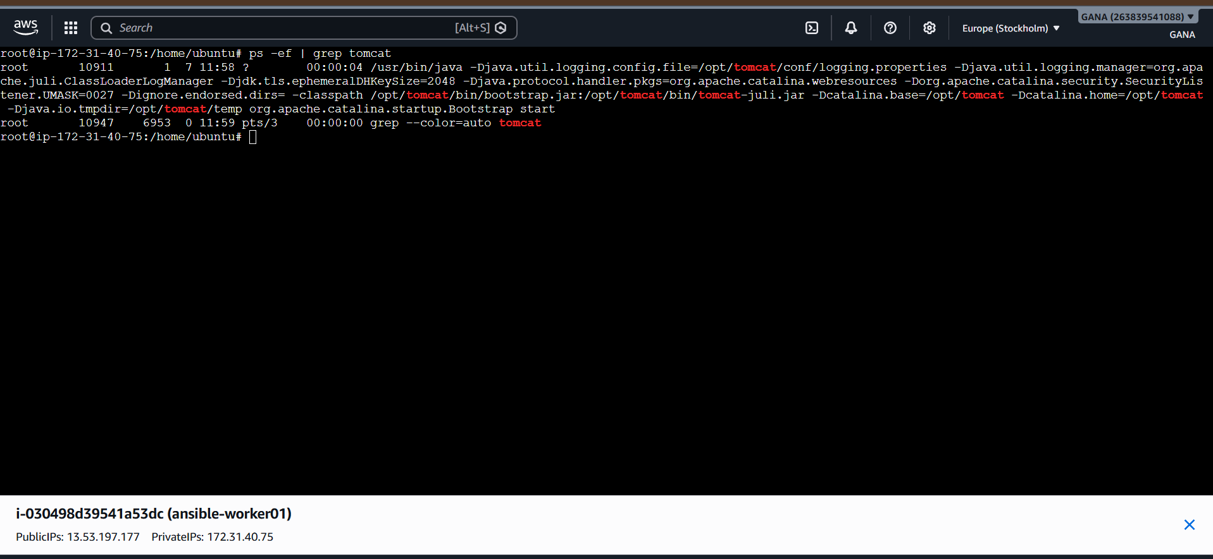
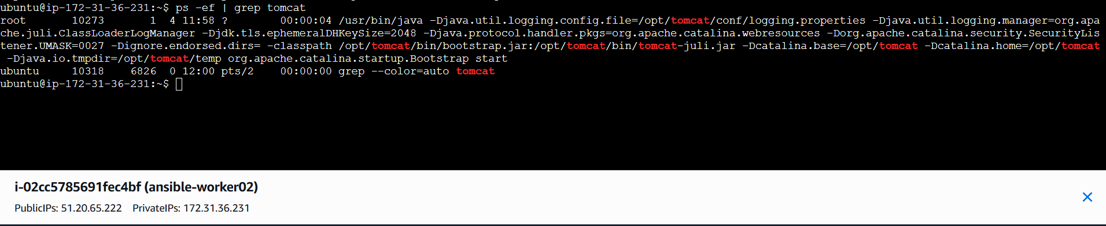
Or:
netstat -tulnp | grep 8080
Expected:
8080 LISTEN

Step 7: Open in Browser
Open:
http://<public-ip>:8080
Example:
http://54.xx.xx.xx:8080
You should see:
Apache Tomcat Default Page ✅
http://13.53.197.177:8080/

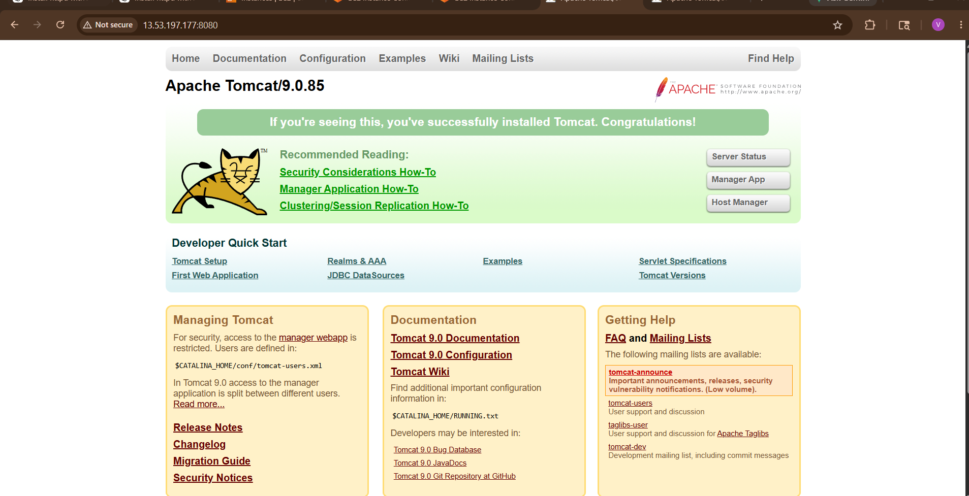

http://51.20.65.222:8080/
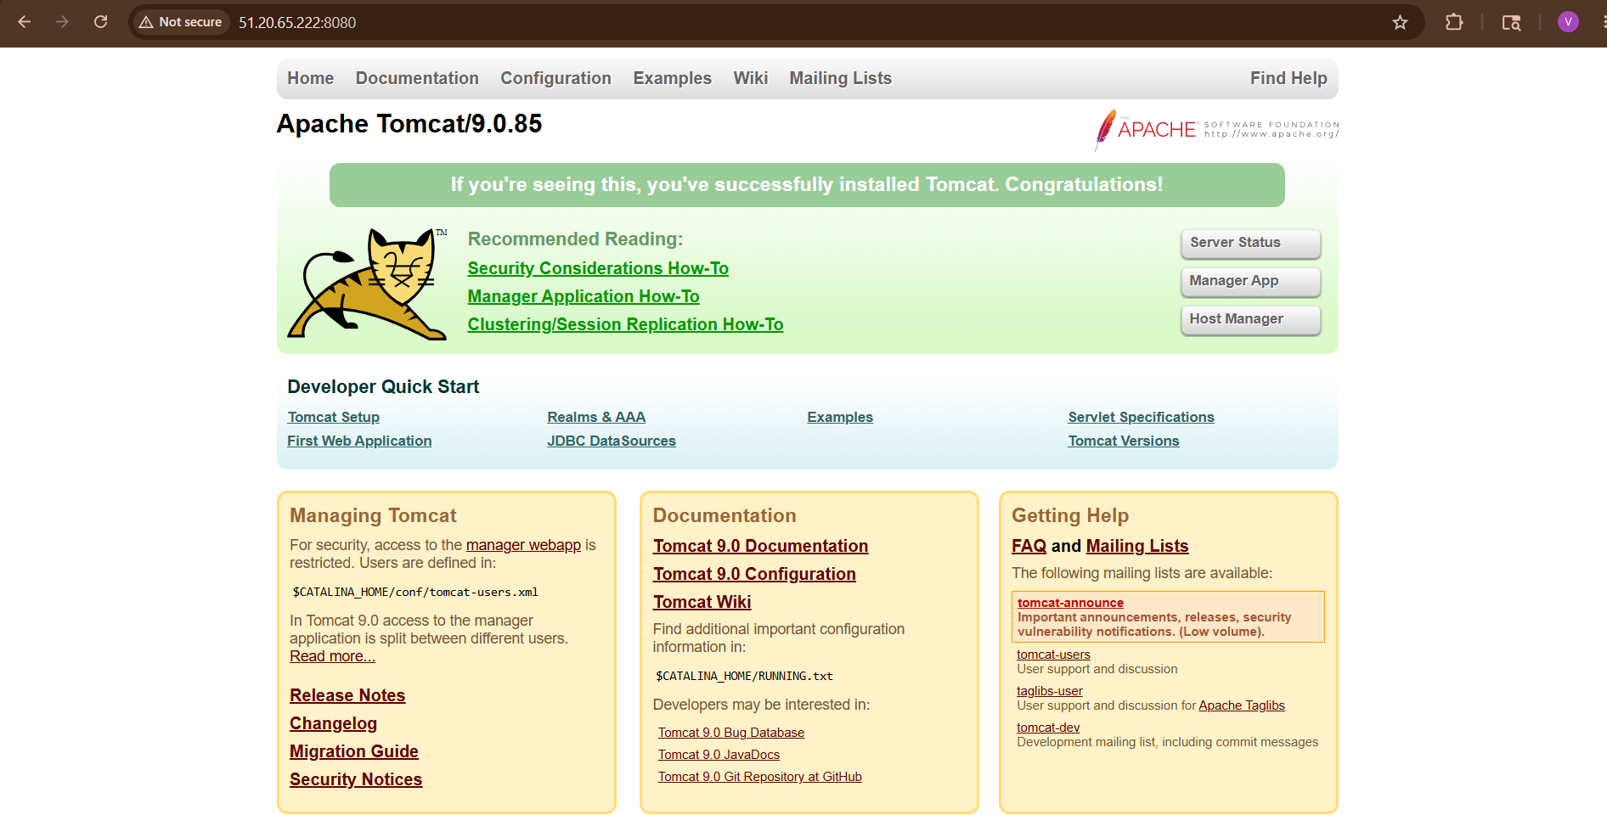

Important AWS Security Group Rule
Allow:
Port | Protocol
8080 | TCP
Go to:
AWS Console → EC2 → Security Groups → Inbound Rules
Add:
Custom TCP
Port: 8080
Source: Anywhere

Explanation of Modules
Module | Purpose
yum | Install Java
file | Create directory
get_url | Download Tomcat
unarchive | Extract tar file
shell | Start Tomcat

Verify Java
java -version

Verify Tomcat Logs
cd /opt/tomcat/logs
ls

Project Structure
tomcat-playbook/
├── hosts
└── tomcat.yml

3 ) Write a ansible playbook to provision one ec2 on aws.
Ansible Playbook to Provision One EC2 Instance on AWS
We will use:
- Amazon Web Services
- Ansible
- Ubuntu EC2 instance
- Ansible amazon.aws.ec2_instance module

Step 1: Launch One Ubuntu Server
Create one Ubuntu EC2 instance manually first.
This server will act as:
- Ansible Controller
Install Ansible on this server.

Step 2: Install Ansible
Login to Ubuntu server:
ssh -i key.pem ubuntu@<public-ip>
Update packages:
sudo apt update -y

Install Ansible:
sudo apt install ansible -y
Check version:
ansible –version
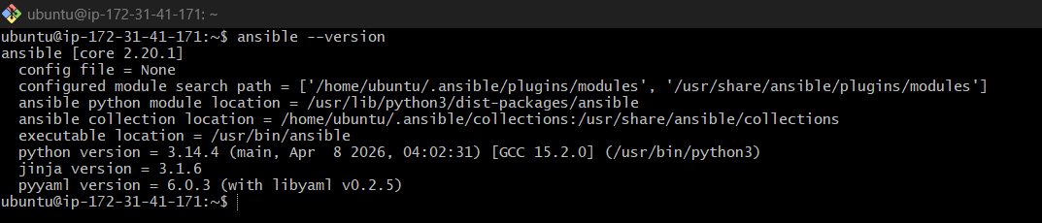

Step 3: Install AWS Collection for Ansible
Install AWS collection:
ansible-galaxy collection install amazon.aws
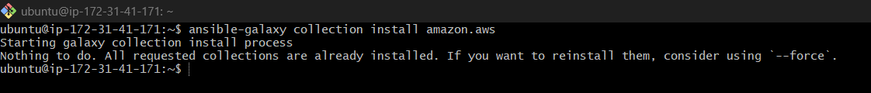
Install boto libraries:
sudo apt install python3-pip -y
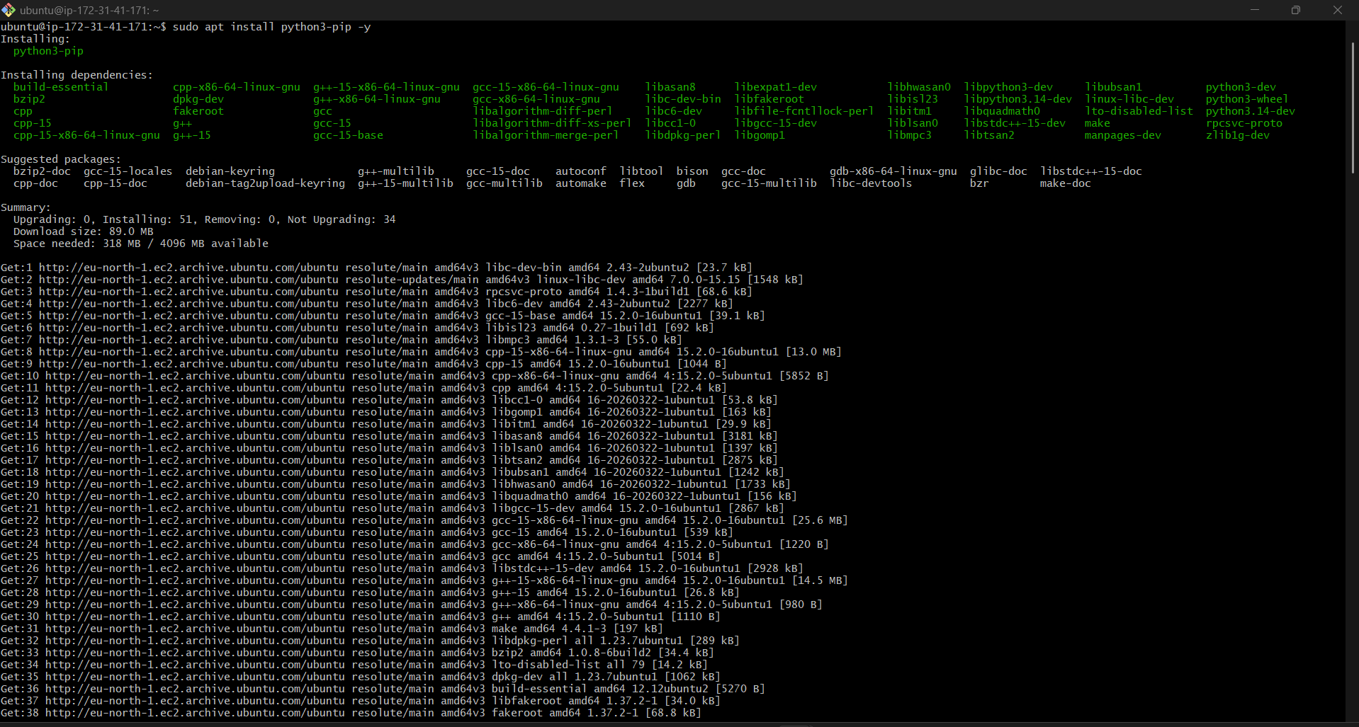
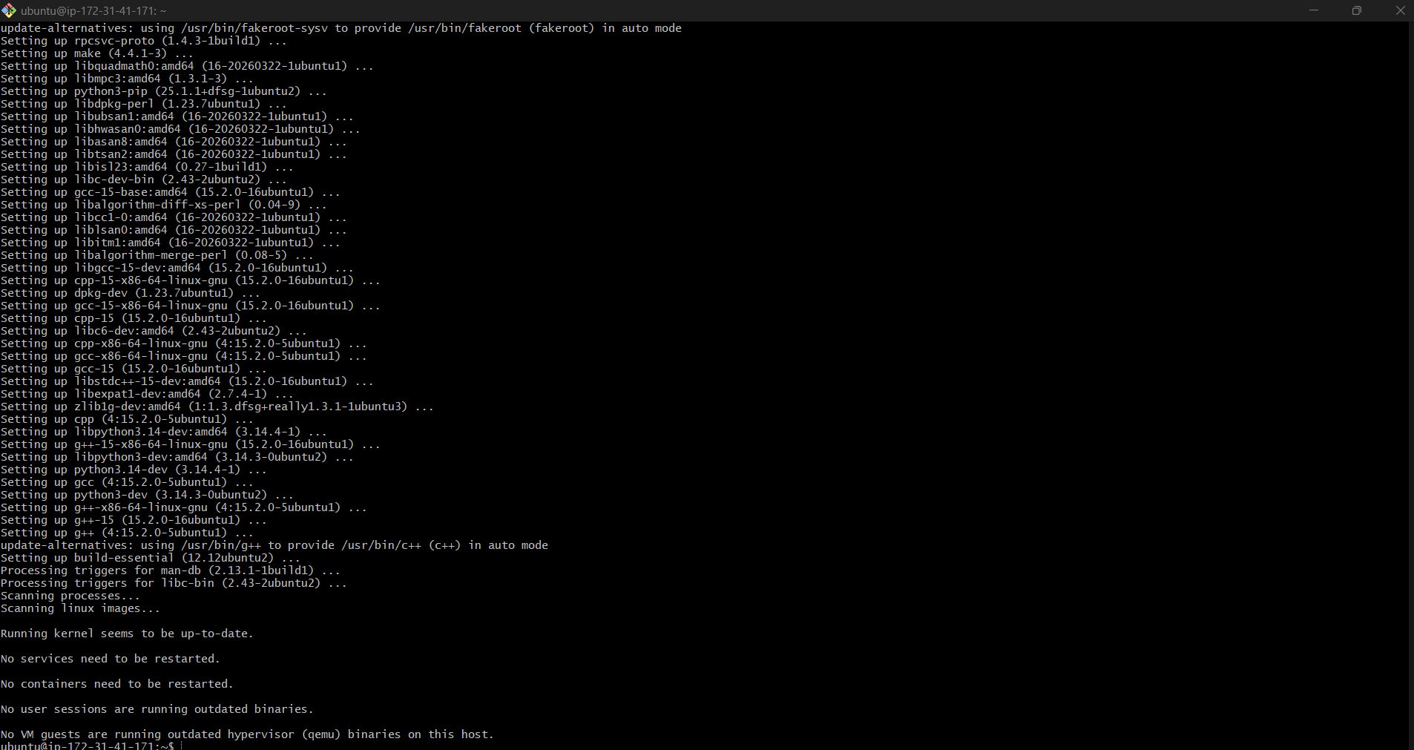
pip3 install boto3 botocore

Step 4: Create AWS IAM User
Go to:
AWS IAM Console
Create IAM user with:
- Programmatic access
Attach policy:
AmazonEC2FullAccess
After creation, copy:
- Access Key
- Secret Key

Step 5: Configure AWS CLI
Install AWS CLI:
sudo apt install awscli -y
Configure credentials:
aws configure

Enter:
AWS Access Key ID
AWS Secret Access Key
Region = ap-south-1
Output format = json
Test:
aws ec2 describe-instances

Step 6: Create Project Directory
mkdir aws-ansible
cd aws-ansible
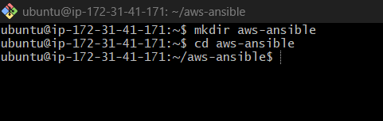

Step 7: Create Ansible Playbook
Create file:
nano ec2.yml

below playbook:
---
- name: Provision one EC2 instance on AWS
hosts: localhost
connection: local
gather_facts: false
vars:
region: eu-north-1
instance_name: ansible-ec2-server
instance_type: t3.micro
ami_id: ami-063f61adbae382edf
key_name: ansible
security_group: ansible-sg
tasks:
- name: Create security group
amazon.aws.ec2_security_group:
name: "{{ security_group }}"
description: Allow SSH and HTTP
region: "{{ region }}"
rules:
- proto: tcp
ports:
- 22
- 80
cidr_ip: 0.0.0.0/0
rules_egress:
- proto: all
cidr_ip: 0.0.0.0/0
register: sg
- name: Launch EC2 instance
amazon.aws.ec2_instance:
name: "{{ instance_name }}"
key_name: "{{ key_name }}"
instance_type: "{{ instance_type }}"
image_id: "{{ ami_id }}"
region: "{{ region }}"
security_group: "{{ security_group }}"
wait: yes
count: 1
tags:
Name: "{{ instance_name }}"
register: ec2
- name: Show EC2 public IP
debug:
msg: "EC2 Public IP is {{ ec2.instances[0].public_ip_address }}"
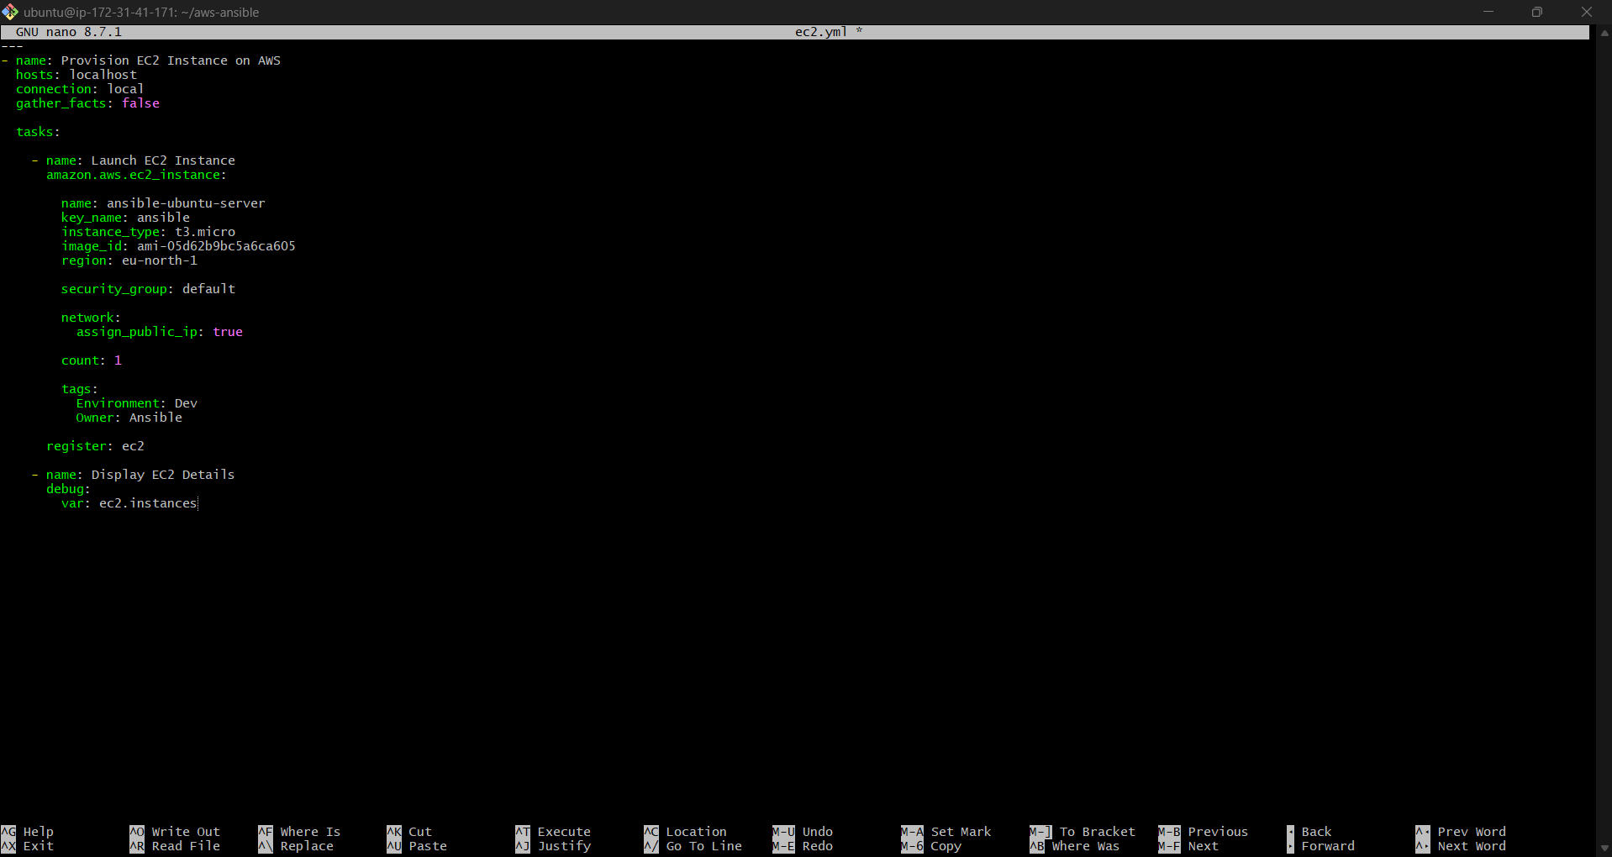

Step 8: Important Values to Change
Change these values:
1. key_name
Replace:
key_name: your-key-name
With your AWS key pair name.
Example:
key_name: mykey

2. image_id
Ubuntu 22.04 AMI for Hyderabad region (ap-south-1):
ami-0f58b397bc5c1f2e8
You can verify latest Ubuntu AMI from:
Ubuntu EC2 AMI Finder

Step 9: Run Playbook
Execute:
ansible-playbook ec2.yml
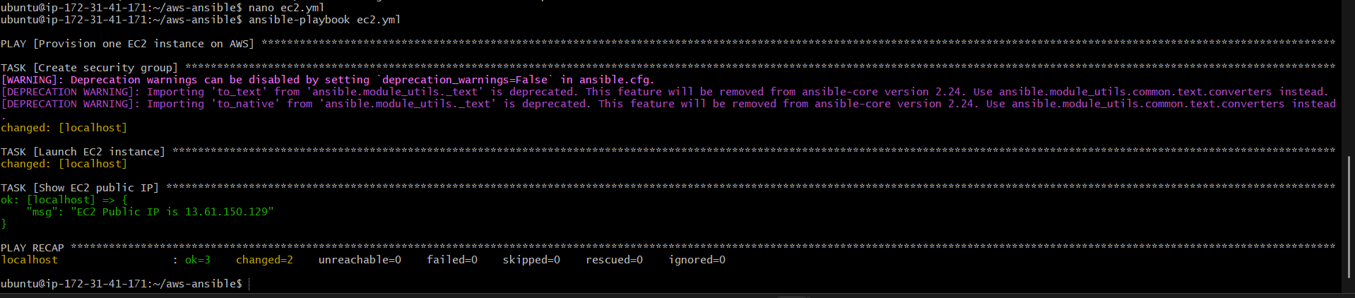

Step 10: Successful Output
You will see:
PLAY RECAP
localhost : ok=2 changed=1 unreachable=0 failed=0

Step 11: Verify EC2 Instance
Go to:
AWS EC2 Console

Check:
- Running instance
- Public IP
- Ubuntu server
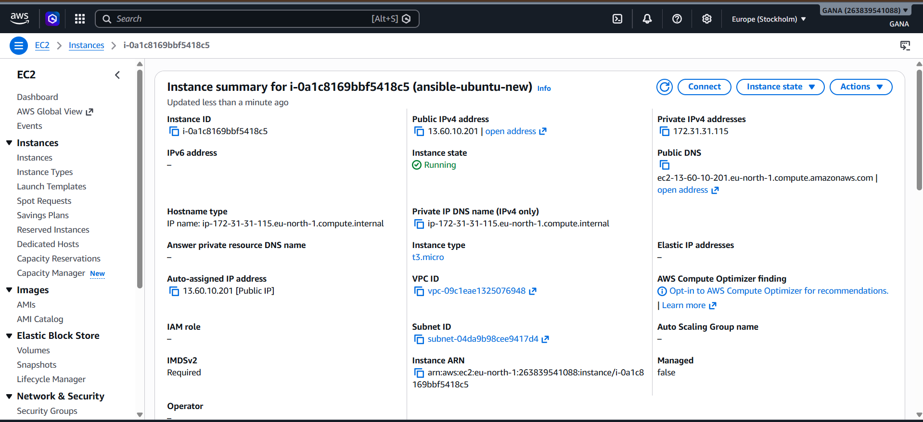

Complete Folder Structure
aws-ansible/
└── ec2.yml

Advanced Version (With Security Group)
---
- name: Create EC2 with Security Group
hosts: localhost
connection: local
gather_facts: false
tasks:
- name: Create Security Group
amazon.aws.ec2_security_group:
name: ansible-sg
description: Security Group for Ansible EC2
rules:
- proto: tcp
ports:
- 22
cidr_ip: 0.0.0.0/0
- proto: tcp
ports:
- 80
cidr_ip: 0.0.0.0/0
region: ap-south-1
register: sg
- name: Launch EC2 Instance
amazon.aws.ec2_instance:
name: ansible-ubuntu
key_name: your-key-name
instance_type: t2.micro
image_id: ami-0f58b397bc5c1f2e8
region: ap-south-1
security_group: ansible-sg
network:
assign_public_ip: true
register: ec2
- debug:
var: ec2.instances

4) Write a ansible playbook to copy one file from node-1 to node-2.
Ansible Playbook to Copy File from Node-1 to Node-2
Using Ansible, we will:
- Create file in node-1
- Copy it to node-2

Architecture
Ansible Controller
|
-------------------------
| |
Node-1 Node-2
(Source) (Destination)

Step 1: Verify Connectivity
From controller machine:
ansible all -m ping

Expected output:
SUCCESS
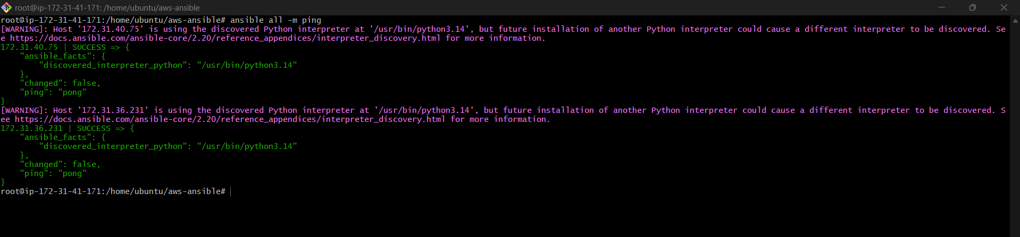

Step 2: Create Inventory File
Go to Ansible directory:
cd /etc/ansible
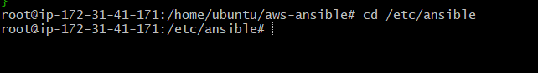
Edit hosts file:
sudo nano hosts
Add:
[node1]
172.31.40.75
[node2]
172.31.39.156
Replace IPs with your server IPs.
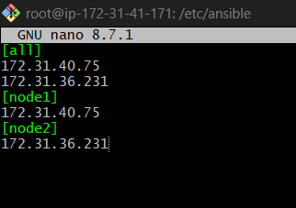

Step 3: Create Sample File in Node-1
Login to node-1:
ssh ubuntu@172.31.40.75
Create file:
echo "Welcome to Ansible File Transfer" > /tmp/testfile.txt
Verify:
cat /tmp/testfile.txt
Exit:
Exit
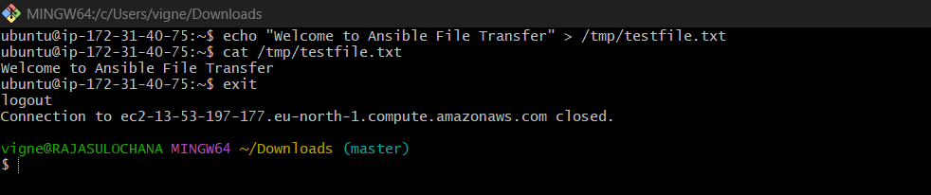

Step 4: Create Playbook ( Master)
Go to home directory:
cd ~
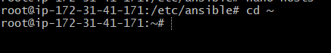
Create playbook:
nano copyfile.yml


Step 5: Add Playbook Content
Paste this:
---
- name: Copy file from Node1 to Node2
hosts: node2
become: yes
tasks:
- name: Copy file from node1 to controller
fetch:
src: /tmp/testfile.txt
dest: /tmp/
flat: yes
delegate_to: 172.31.40.75
- name: Copy file from controller to node2
copy:
src: /tmp/testfile.txt
dest: /tmp/testfile.txt
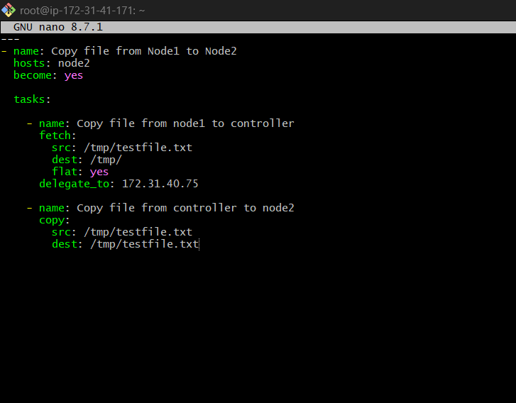

Step 6: Save File
Inside vi:
ESC
Type:
:wq

Step 7: Run Playbook
ansible-playbook copyfile.yml
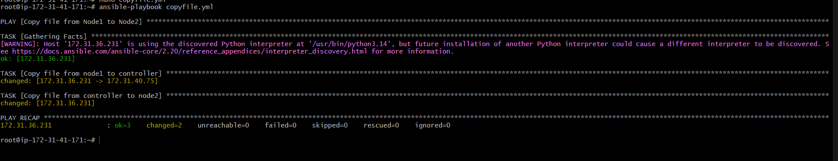

Step 8: Verify in Node-2
Login to node-2:
ssh ubuntu@172.31.39.156
Check file:
cat /tmp/testfile.txt
Expected output:
Welcome to Ansible File Transfer
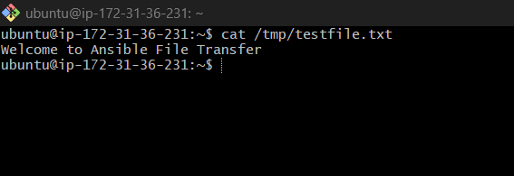

Important Modules Used
fetch module
Copies file:
Remote Machine → Controller

copy module
Copies file:
Controller → Remote Machine

5) Write a ansible playbook to create different files with different names using single playbook.

Ansible Playbook to Create Different Files with Different Names Using Single Playbook
Using Ansible we can create multiple files using a loop in one playbook.

Goal
Create files like:
file1.txt
file2.txt
file3.txt
test.log
demo.txt
using one playbook.

Step 1: Login to Ansible Master
ssh ubuntu@<master-ip>

Step 2: Verify Connectivity
Check all nodes:
ansible all -m ping
Expected:
SUCCESS
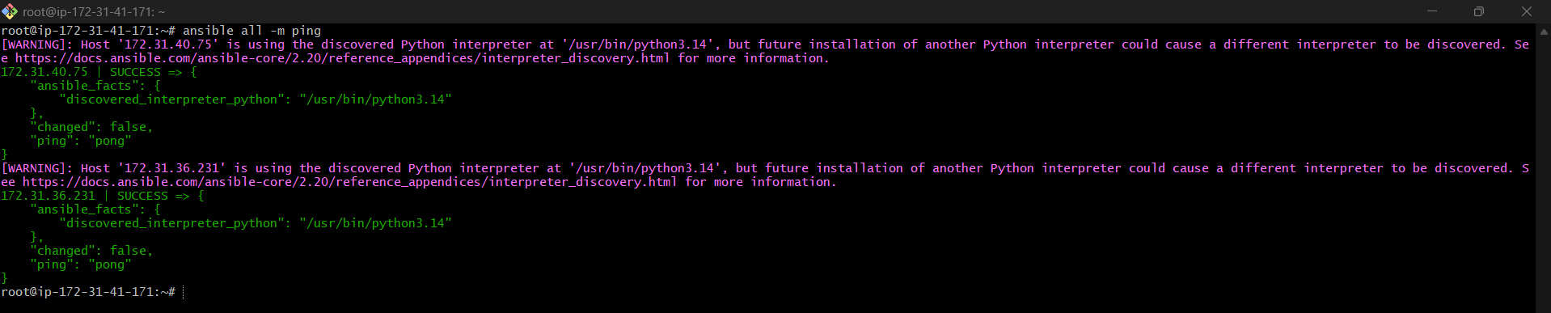

Step 3: Create Playbook File
Go to home directory:
cd ~
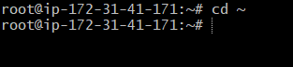
Create playbook:
nano createfiles.yml

Step 4: Add Playbook Content
Paste this:
---
- name: Create Multiple Files
hosts: all
become: yes
tasks:
- name: Create different files
file:
path: "/tmp/{{ item }}"
state: touch
loop:
- file1.txt
- file2.txt
- file3.txt
- test.log
- demo.txt
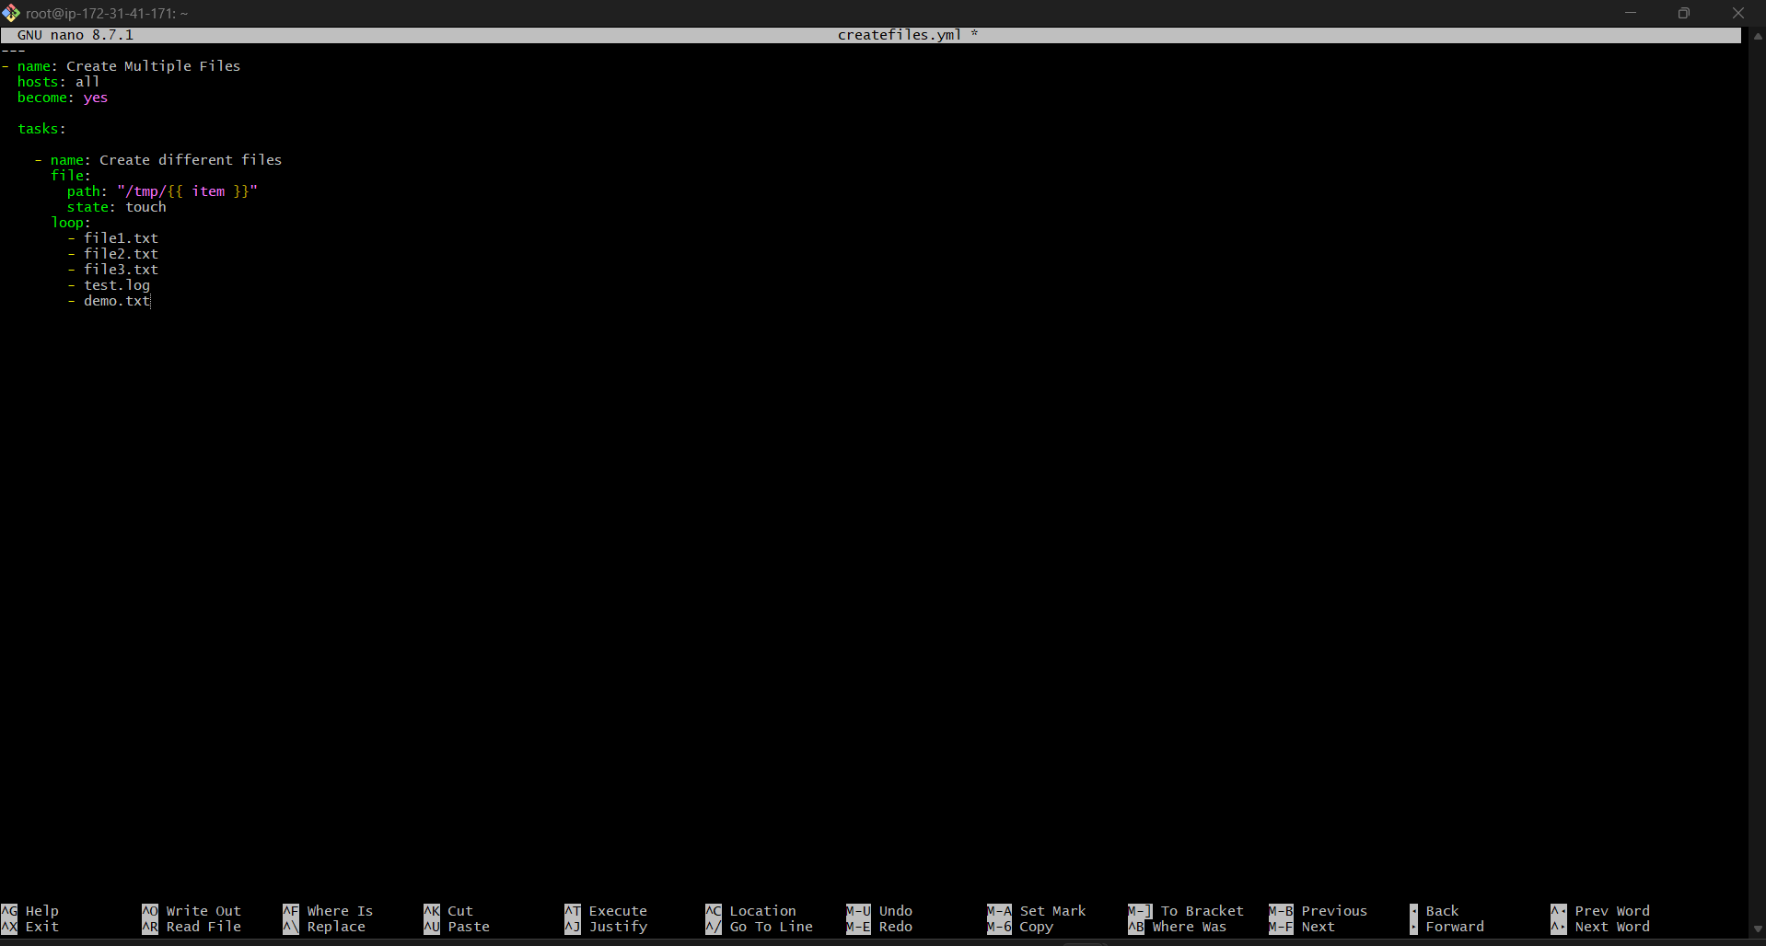

Explanation
file module
Used to create files/directories.

state: touch
Creates empty file.

loop
Creates multiple files using one task.

Step 5: Save File
Inside vi:
ESC
Type:
:wq
Press Enter.

Step 6: Run Playbook
ansible-playbook createfiles.yml
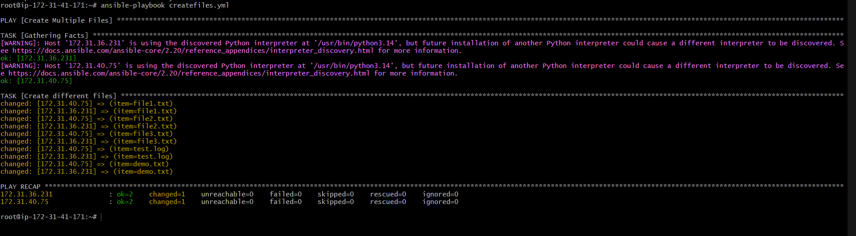

Step 7: Verify Files
Login to node:
ssh ubuntu@<node-ip>

Check files:
ls /tmp
Expected output:
file1.txt
file2.txt
file3.txt
test.log
demo.txt

Advanced Example (Different Paths)
---
- name: Create Multiple Files in Different Locations
hosts: all
become: yes
tasks:
- name: Create files
file:
path: "{{ item }}"
state: touch
loop:
- /tmp/app.log
- /home/ubuntu/demo.txt
- /opt/test.sh

